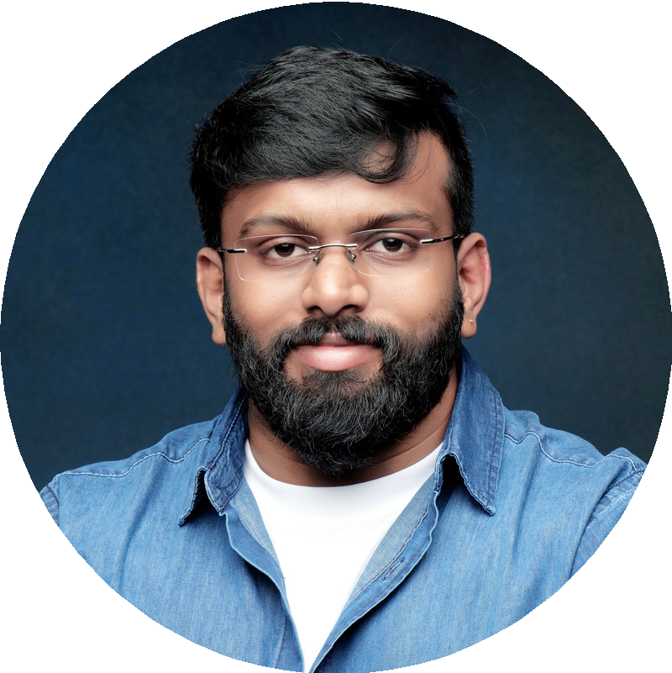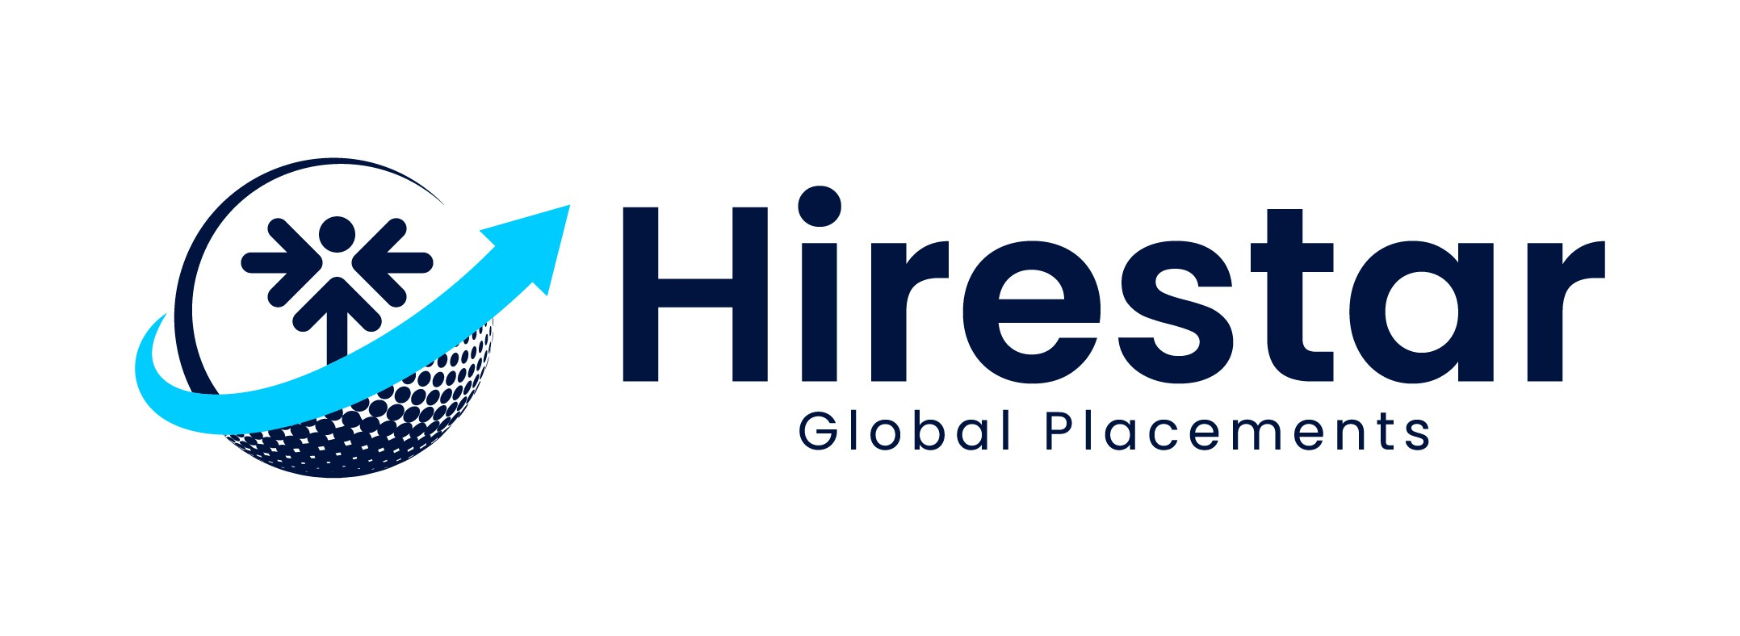

AJ I T H S KUMAR
PERF ORMANCE MARKET I NG SPECI ALI ST

CONT ACT
+91 7994553585


ajithskumar.619@gmail.com Thiruvalla

www.linkedin.com/in/ajith-s-
kumar-25m1996

I am a dedicated Performance Marketing Specialist with a passion for driving results through strategic digital campaigns. I excel in optimizing paid media channels, analyzing data to improve performance, and delivering measurable growth. With a focus on ROI and continuous learning, I thrive in fast-paced environments where I can make an impact.
PROF ESSI ONAL PROF I LE

EXPERT I SE SKI LLS
EXPERI ENCE
Google Ads Meta Ads
Wordpress SEO
Unbounce
Tik Tok Ads. Respond.io
LinkedIn Ads.
Whatsapp Ads. A/B Testing

LANGUAGE

English Hindi

SKI LL
Team Mentoring
Project Management CRM Management
Budget Management
Marketing Automation & Integration

Global Nurse Force
Performance Marketing Specialist
July 2024 - Present
Handled multiple digital accounts (Global Nurse Force, Global Med Force, GNF Career Pathways), focusing on maximizing ROI through strategic planning and optimization.
Skilled in managing Zoho CRM to organize and streamline customer data and processes.
Experienced in designing and optimizing landing pages through Unbounce to improve conversions and support marketing campaigns.
Proficient in using Zapier to integrate CRM with other tools and automate workflows.
Focused on leveraging tools and strategies to achieve measurable marketing results.

Pushpagiri Medical College Hospital Digital Marketing Executive
March 2018 - June 2024
EDUCAT I ON

Bachelor of Computer Application
University of Madras (2018 - 2021)

